Chapter 7:
Purchasing

Objectives

After completing this section, you will be able to:

- Create / Edit / Review / Approve Requisitions
- Create / Edit / Review / Approve / Complete Purchase Orders

Contents
Purchasing 237
Requisitions 237
Adding Tracked Inventory Items to a Requisition 239
Adding Non-Tracked Inventory Items to a Requisition 239
Approving/Rejecting a Requisition 240
Converting a Requisition to a Purchase Order 241
Purchase Orders 242
Adding Tracked Inventory Items to a Purchase Order 242
Adding Non-Tracked Inventory Items to a Purchase Order 242
Adding Requisition Items to a Purchase Order 242
Release Purchase Order to Supplier 242
Acknowledge Purchase Order 243
Cancel Purchase Order 243
Receive Against a Purchase Order 243
Table of Figures
Figure 1 Requisitions Viewer 237
Figure 2 Requisition Detail Screen 238
Figure 3 Requisition Item Detail Screen 238
Figure 4 Requisition Item Viewer Prior to Approvals 240
Figure 5 Requisition Item Viewer Post Approval/Rejection 240

Purchasing

TME Purchasing allows you to automatically create requisitions and purchase order release forms to quickly and accurately order supplies, spare parts and contractor services. Purchase orders can be printed or simply emailed ensuring you have the supplies or services you need on time
In the Purchasing module users are able to add, edit, delete, acknowledge and release Requisitions and Purchase orders. This module can be accessed via Go To from the Task Bar or the appropriate Menu Group.
It consists of two submodules, Requisitions and Purchase Orders. The Requisitions are used primarily by Users to make requests from those with authority to purchase. Items are added and can be from numerous suppliers on a single form. The Purchase Orders are used to order items from a single supplier and then in turn received against within the Inventory Module.

Requisitions
New Requisitions can be added by clicking on at the left side of the Viewer Toolbar, the New Requisition Item icon on the Main Toolbar, or the New Requisition Item icon from the New dropdown list on the Taskbar.
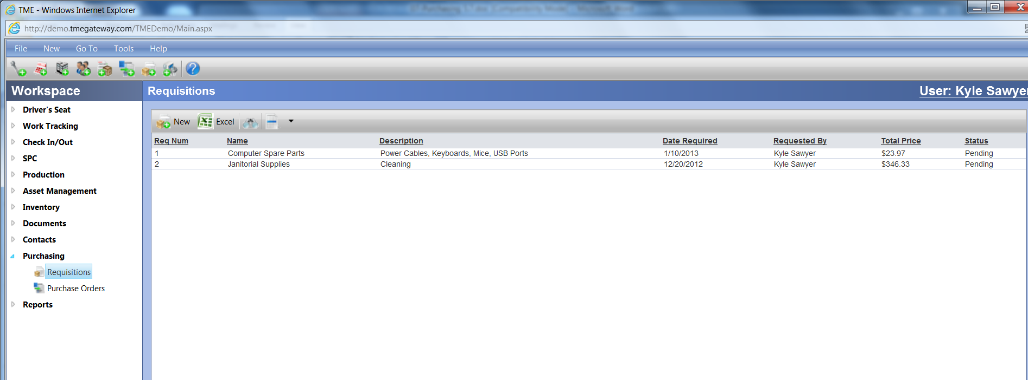
Figure 1 Requisitions Viewer

Type in the details--Name (required), Description, and if applicable, Work Order ID (if the Work Order number is not valid, a popup message will appear indicating the need for an alternate number) and Comments. Select the Effective, Required and Expiration Dates by clicking on the corresponding calendar icons. Select the Location, Priority, Type, Ship To (required), Carrier, and Method from the drop-down lists. If applicable, select an Asset for which the Items are being requisitioned. For questions or suggestions regarding the drop-down lists, contact the company TME Administrator.
The Requestor information is automatically populated with the Name, Email, Phone and Dept. as provided by the logged-in User's profile. If you are creating the Requisition at the request of another User or fields are blank, information can be typed in to override.
Just as with Assets, Inventory and Work Orders, an unlimited number of Attributes can be set up to collect additional information. Click on the Attributes tab.

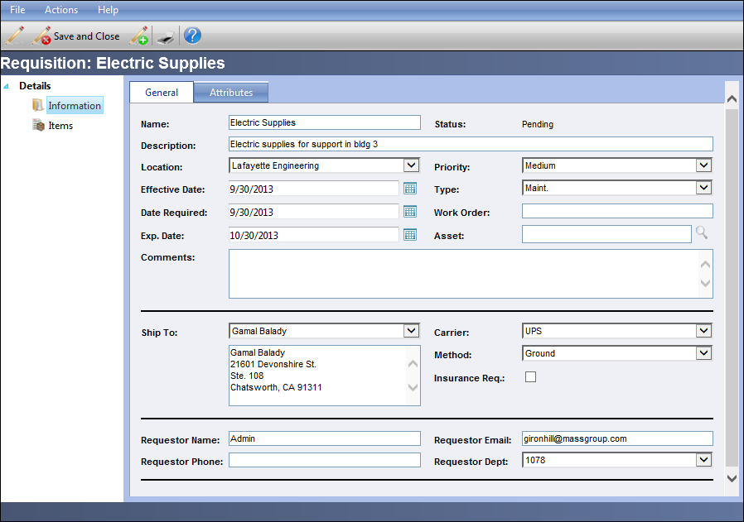
Figure 2 Requisition Detail Screen

Adding Tracked Inventory Items to a Requisition
Items can be added to a Requisition by clicking on the Items link on the Requisition Detail screen. Click on on the viewer toolbar.
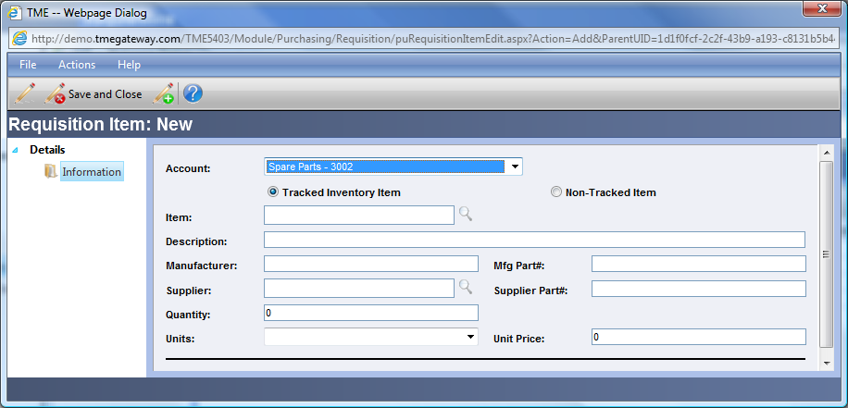
Figure 3 Requisition Item Detail Screen
Select an Account from the drop down list (populated by the TME Administrator). Select an Item from the Item LookUp screen. Any fields that don't automatically populate can then be typed in or have a selection made. Type in the Quantity to be ordered and select the Unit of measurement for that quantity. Be careful regarding the Unit Price if it is pre-populated. It is pulled from the order price of the Supplier screen from the Inventory Item Detail Screen. The Order Price is based on the Order Unit of measure – if you change the unit of measure, you’ll need to change the price. To verify correct price for the Units selected, click on the Inventory Item link, then the Suppliers Additional link, double-click on the Supplier name to open the Detail Screen. The Order Unit and Price will be displayed.

Adding Non-Tracked Inventory Items to a Requisition
Items that are not tracked in the Inventory Module can be added to a Requisition as well. Check the checkbox for Non-Tracked Items. The screen will adjust accordingly. Type in the Name of the item, Description, Manufacturer, Mfg Part Number, Supplier Part #, Quantity, Unit of Measure, and Unit Price. Select the Supplier.

Exercise 1:
 Add three Requisitions with three inventory items and two non-tracked items each.

Approving/Rejecting a Requisition
Requisitions and the Requisition Items can be either Approved or Rejected by Users who have been provided the appropriate permissions. Only those Items that have been approved will be available for inclusion on a Purchase Order. Entire Requisitions can be approved or rejected via Actions on the Requisition Task Bar by clicking on Approved or Rejected. Both actions can be reversed by clicking on to the left of the Item name (must do so for each individual item) on the Requisition Items screen (click on the Items additional link on the Requisition Detail screen). Once all items are returned to pending, the Requisition can then as a whole be Approved or Rejected.
To Approve and/or Reject Items on an individual basis, click on the Items link on the Requisition Detail screen. To approve an item, click on the to the left of the Item name. The status of the item will change from Pending to Approved and the icon will change to . To Reject an Item, click on . The status of the item will change from Pending to Rejected and the icon will change to . To reverse the actions, click on to the left of the Item name and reselect Approve or Reject.
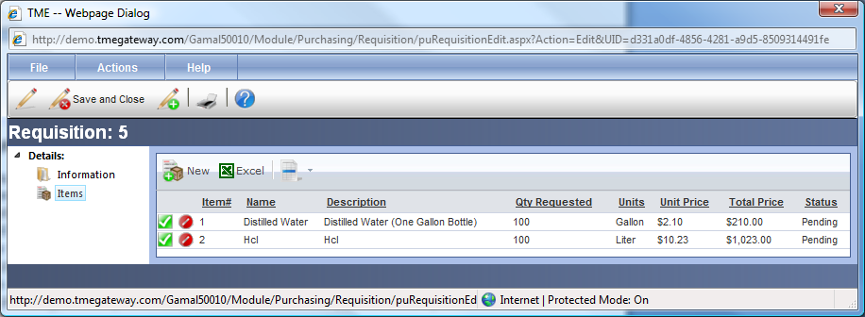
Figure 4 Requisition Item Viewer Prior to Approvals
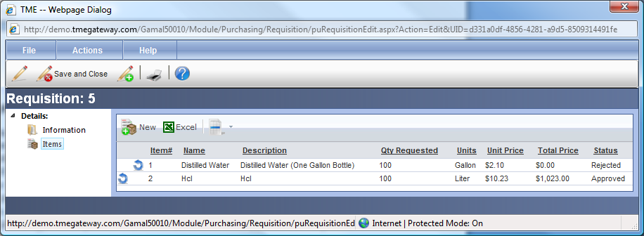
Figure 5 Requisition Item Viewer Post Approval/Rejection

Once all items have either been Approved or Rejected, the status of the Requisition itself will change from Pending to Processed.

Converting a Requisition to a Purchase Order
To convert an entire Requisition to a Purchase Order, the items must all be from the same supplier (Purchase Orders are done for a single supplier).
Open the Requisition, click on Actions and then Generate PO. A popup message appears stating that the PO was created and providing its ID number. Click OK and both the popup message and Requisition Detail screen close. The status of the Requisition changes to Committed and no more changes to the Requisition will be accepted.
Requisition Items can be individually selected for a Purchase Order via the Purchase Order Module.

Exercise 2:
Approve one Requisition in its entirety and approve three items and reject two items on another.

Exercise 3:
Convert the third Requisition to a Purchase Order.

Purchase Orders
New Purchase Orders can be added by clicking on at the left side of the Viewer Toolbar, the New Purchase Order Item icon on the Main Toolbar, or the New Purchase Order Item icon from the New dropdown list on the Taskbar.
Setting up the Purchase Order works the same as for a Requisition with the exception that the Supplier must be selected for the entire Purchase Order as opposed to each Item. Also, a drop-down list is available to select Billing Information.

Adding Tracked Inventory Items to a Purchase Order
Items can be added to a Purchase Order by clicking on the Items link on the Purchase Order Detail screen. Click on on the viewer toolbar. Keep the checkbox for Tracked Inventory Item checked. Select the Item. Any fields that don't automatically populate can be typed in or have a selection made. As with the Requisitions, be careful regarding the Unit Price if it is pre-populated and you may need to change the unit of measure.

Adding Non-Tracked Inventory Items to a Purchase Order
To add items not stored in Inventory, check the checkbox for Non-Tracked Items. The screen will adjust accordingly. Type in the Name of the item, Description, Manufacturer, Mfg Part Numb, Supplier Part #, Quantity, Unit of Measure, and Unit Price.

Adding Requisition Items to a Purchase Order
Items that have been requisitioned can be added to a Purchase Order by clicking on the Items link on the Purchase Order Detail screen. Click on to open up the Item LookUp screen with all of the Approved Requisition Items that have not been selected previously for a Purchase Order. Click on to the left of the Item Name. To add additional Requisition Items, repeat the process.

Release Purchase Order to Supplier (Prerequisite for Receiving)
To release a Purchase Order to a Supplier, open the Purchase Order. Click on "Release to Supplier" from Actions on the Task Bar. A popup message will appear with "Are you sure you want to release the purchase order?" Click OK to continue. A popup message will appear with "Purchase Order Released." Click OK to close the popup message. Click on on the toolbar to print (prints to a pdf file, so you can save and then email to vendor). The status of the Purchase Order changes from Pending to Released and the Purchase Order is now available for selection in Inventory Receiving.

Acknowledge Purchase Order
Once a Supplier has received and acknowledged a Purchase Order, the status of the Purchase Order can be changed to Acknowledged. Open the Purchase Order and click on "Acknowledge" from Actions on the Task Bar. A popup message will appear with "Are you sure you want to acknowledge the purchase order?" Click OK to continue. A popup message will appear with "Purchase Order Acknowledged." Click OK to close the popup message. The status of the Purchase Order changes from Released to Acknowledged.

Cancel Purchase Order
At any time, a Purchase Order can be cancelled. Open the Purchase Order and click on "Cancel" from Actions on the Task Bar. A popup message will appear with "Are you sure you want to cancel the purchase order?" Click OK to continue. A popup message will appear with "Purchase Order Cancelled." Click OK to close the popup message. The status of the Purchase Order changes to Cancelled.

Receive Against a Purchase Order
Items are received against a Purchase Order via the Inventory Receiving submodule once the Purchase Order has been released to the vendor. As Items are received, the status of the Purchase Order changes to either Partially Received or Received.

Exercise 4:
Convert the third Requisition to a Purchase Order. Add three more items. Release to Vendor, receive three of the items as well as half of the quantity of a fourth item. Check status of Purchase Order throughout the process.

Exercise 5:
Receive the rest of the Items from the Purchase Order used in Exercise 4. Verify that the Purchase Order status is set to Received.

Exercise 6:
You need to build your Kit by next week and do not have the Inventory Items necessary. Complete the process from requesting the Items to placement into My Inventory.

